The 2024-2025 season started with a couple of summer activities for the Patrol. We enjoyed a group outing to a Louisville Bats (Cincinnati Reds AAA) baseball game in the late summer and we also had a water sports and cookout at Monroe Reservoir in Bloomington Indiana.

We started our hybrid OEC class in August. That class was let by Joe Collins (IOR) and Cary Gant. We started with 7 candidates and for the first time since I’ve been on the patrol, we finished with the same number of Patrollers. 100% retention is fairly rare and I think it speaks to a job well done by the IOR and the Paoli instructors.

In late fall we executed our instructor (November 2nd) and OEC (November 16th) refreshers and both were well organized by John Nassar (IOR). Since our refresher was the last on the schedule in the Ohio region we were visited by a multitude of patrollers from the Central Division. It’s always nice to interact with patrollers outside our territory.

The season kicked off early for us on December 21st and we were blessed to only have a short bit of downtime in early January. The patrol finished with 68 days of operations…which is the most we’ve had in 10 years or more. The long season was what we desperately needed as a patrol as we had 18 patrollers (black jackets) who still needed to complete their Alpine status. Our instructors made a concerted effort to push hard on the OET training and by the end of the year were able to convert 6 patrollers to a new Alpine Patroller status. Also, for the first time in many years we were able to host all our scheduled trainings SES, TES, and TTW (January 18th – 19th).

At the beginning of the season Paoli management supplied us a with wish list of materials to add some much-needed storage and locker space to our back patrol room. Previously our patrollers had to bring their gear (boots, helmets, and patrol uniform) every time they skied. We worked on the project throughout the season and are 95% finished. We’re waiting for urethane to be purchased so we can waterproof and protect our units. Below are a couple pictures of the room. Our plans are to have these finished in the off season. Once these are completed, each patroller will have their own storage tub and hanging space to keep all their patrol gear on site.

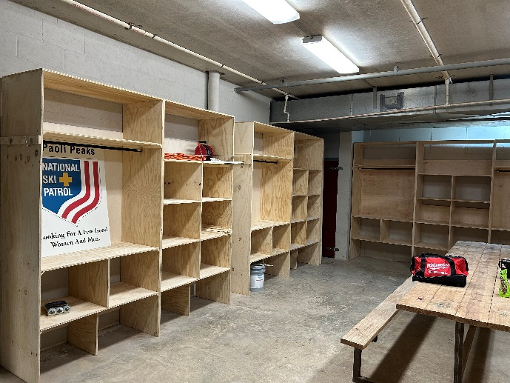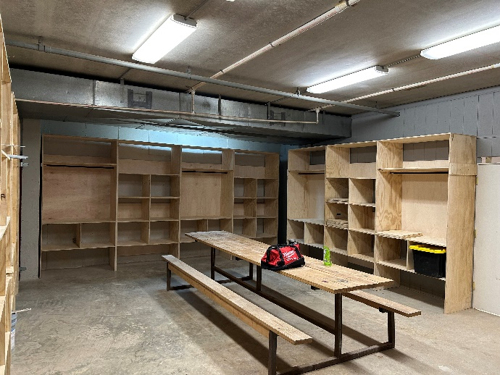

Overall last season was one of the most productive seasons we’ve had in many years.