***Cuyahoga Nordics 2024-2025 Season Summary***

The Cuyahoga Nordics Ski patrol has experienced a bit of a renaissance this past season. While mother nature has not been a kind in terms of consistent, snowy conditions our partnership with the Lake County Metroparks continues to grow. Additionally, the partnership between the Cuyahoga Nordics Ski Patrol and the Boston Mills, Brandywine, Alpine Valley Ski Patrol continues to be exceptionally strong. Primary members of the Cuyahoga Nordics serve as secondary patrollers with BMBWAV Ski Patrol and hold leadership positions including OEC Instructor and Hill / Shift Captain.

There are several key highlights:

* The Cuyahoga Nordics developed and launched a new website. The aim of which is to increase awareness of the local patrol across the region, seek to attract new patroller talent, and increase visibility to both Nordic Patrolling and Nordic Winter Snowsports. Initial results have been quite positive, with an increase in secondary membership of several patrollers.

<https://sites.google.com/kent.edu/cuyahoga-nordics-ski-patrol/home>

* The Cuyahoga Nordics have also begun exploration of a stronger partnership with PSIA-AASI seeking to host Nordic teaching events for patrollers and non-patrollers alike wanting to improve their Nordic Skiing skills.
* Finally, our partnership with Lake County Metroparks continues. The past two seasons we have had increased engagement with the Chapin Forest (Pine Lodge Cross-Country Ski Center) Team sharing more of the NSP training protocols with them while they are sharing more of both their operating procedures and future development plans.
  + Chapin Forest Information:
    - Pine Lodge Cross-Country Ski Center is located at 10381 Hobart Road, Kirtland, Ohio 44094
    - *If your adventure includes cross-country skiing, there are opportunities across the county starting with*[*Chapin Forest Reservation*](http://www.lakemetroparks.com/parks-trails/chapin-forest-reservation)*where we rent skis and snowshoes, groom the trails and turn on lights for you at night. If you have “been there and done that” and want to experience the peace and solitude that exists throughout winter, you might check out three other areas groomed for skiing. In south/central Lake County we groom nine kilometers at the south entrance of*[*Girdled Road Reservation*](http://www.lakemetroparks.com/parks-trails/girdled-road-reservation)*–some of it flat, but also some challenging terrain. Each park offers a different experience and, with the spotty nature of snowfall, it may be possible to ski in one park while grass is still showing at another.*
    - <https://www.lakemetroparks.com/events-activities/activities/cross-country-skiing-snowshoeing/>

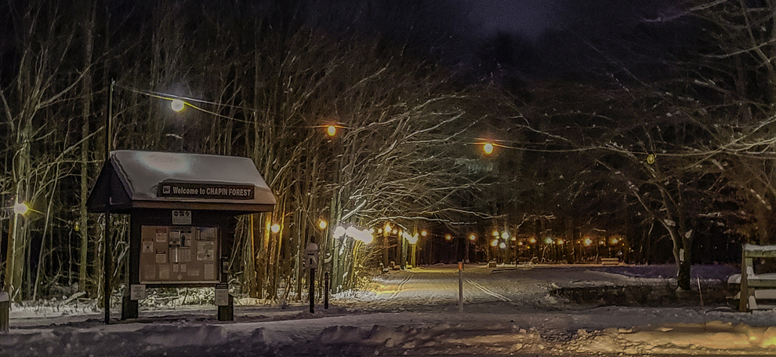

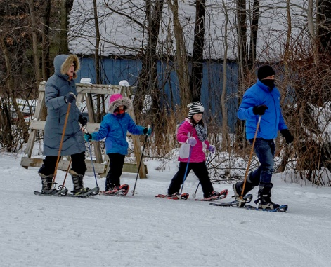

As the Cuyahoga Nordics continues to increase exposure to Nordic Patrolling and the variety of Nordic Snowsport opportunities around Ohio, we expect membership to grow and increased partnership opportunities with Alpine Patrols for training across a variety of NSP programs.

We will also ensure that a more up to date representation of the Cuyahoga Nordics can be found on the Ohio Region NSP site. This description should be updated to reflect current affiliation with the Lake Country Metroparks system. We can work with Rose to make the necessary changes.

*Cuyahoga Nordics Ski Patrol (https://www.ohionsp.org/programs/nordic)*

*The Cuyahoga Nordics Ski Patrol is a volunteer association affiliated with Cuyahoga Valley National Park. Our duties involve hiking/skiing the trails in the Cuyahoga Valley and rendering information and first aid as necessary. Requirements to become a nordic ski patroller include BLS-CPR, Outdoor Emergency Care, Mountain Travel and Rescue, and Avalanche Rescue training. Requirements to become a volunteer with the National Park include participation in a yearly volunteer refresher and satisfying the yearly hours requirement while maintaining your skills as a ski patroller. We are a small and dedicated group of people who enjoy working with the visitors to the National Park and also the fun that comes with cross-country skiing. If you are interested in volunteeering with the National Park and our organization, please contact the Park at 440-546-5996*

Respectfully submitted

Daryl Knauss

Patrol Director – Cuyahoga Nordics